

**Mathematics Specialist**

**Unit 3**

**TEST 1 2016**

**Student name:** _______________________ **Teacher name:** _______________________

**Class:** ________

**Time allowed for this task:** 50 minutes, in class, under test conditions

Section One – calculator-free section – 30 minutes (26 marks)

Section Two – calculator-assumed section – 20 minutes (20 marks)

**Materials required:** Calculator with CAS capability (to be provided by the student)

Standard items: Pens (blue/black preferred), pencils (including coloured), sharpener, correction fluid/tape, eraser, ruler, highlights

Special items: Drawing instruments, templates, notes on one unfolded sheets of   
 A4 paper, and up to three calculators approved for use in   
 WACE examinations

**Marks available:** 46 marks

**Task weighting: 7%**

**Section One – calculator-free section (26 marks)**

**Question 1 (4 marks)**

(a)  (2 marks)

(b)  (2 marks)

**Question 2**  **(6 marks)**

1. .

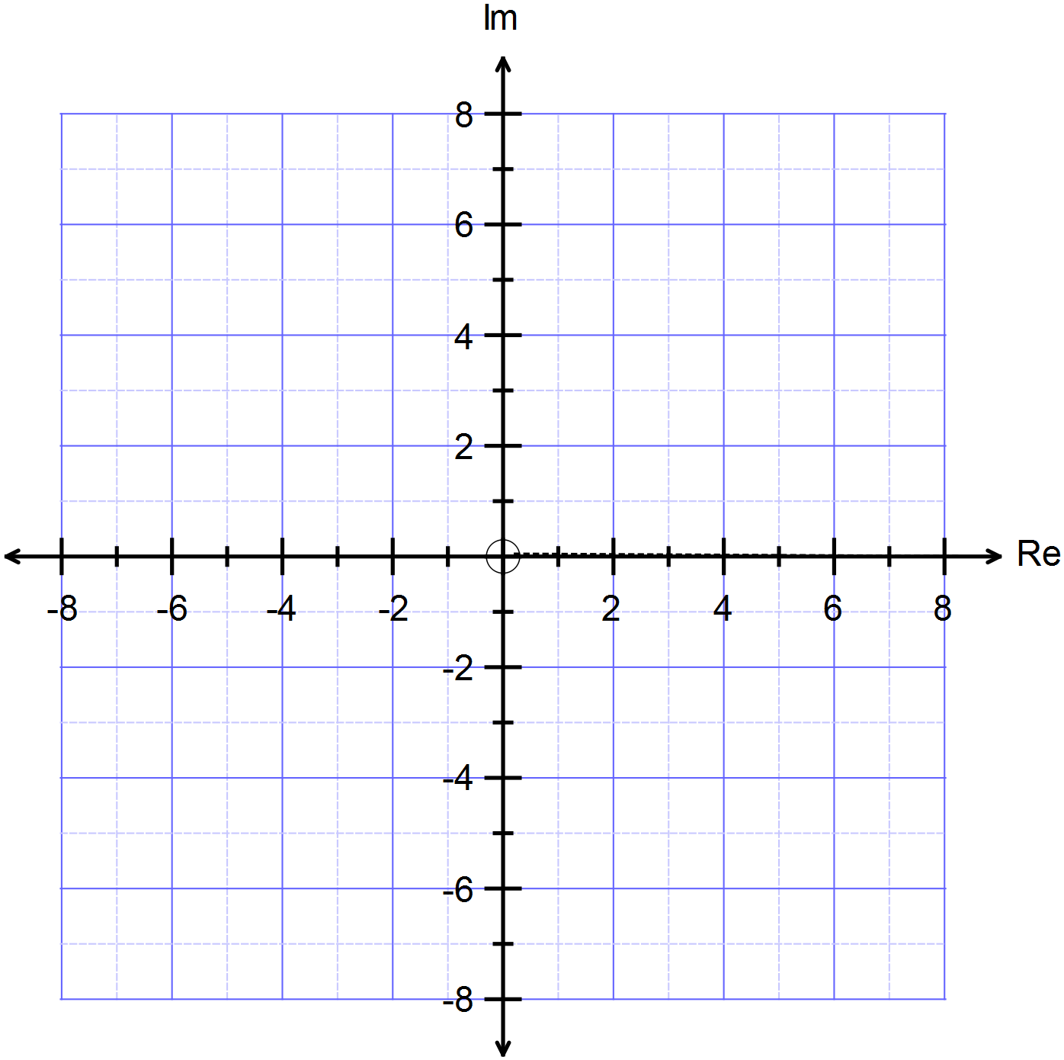

**Question 3 (8 marks)**

Determine and locate all solutions in the Argand plane to the equation . 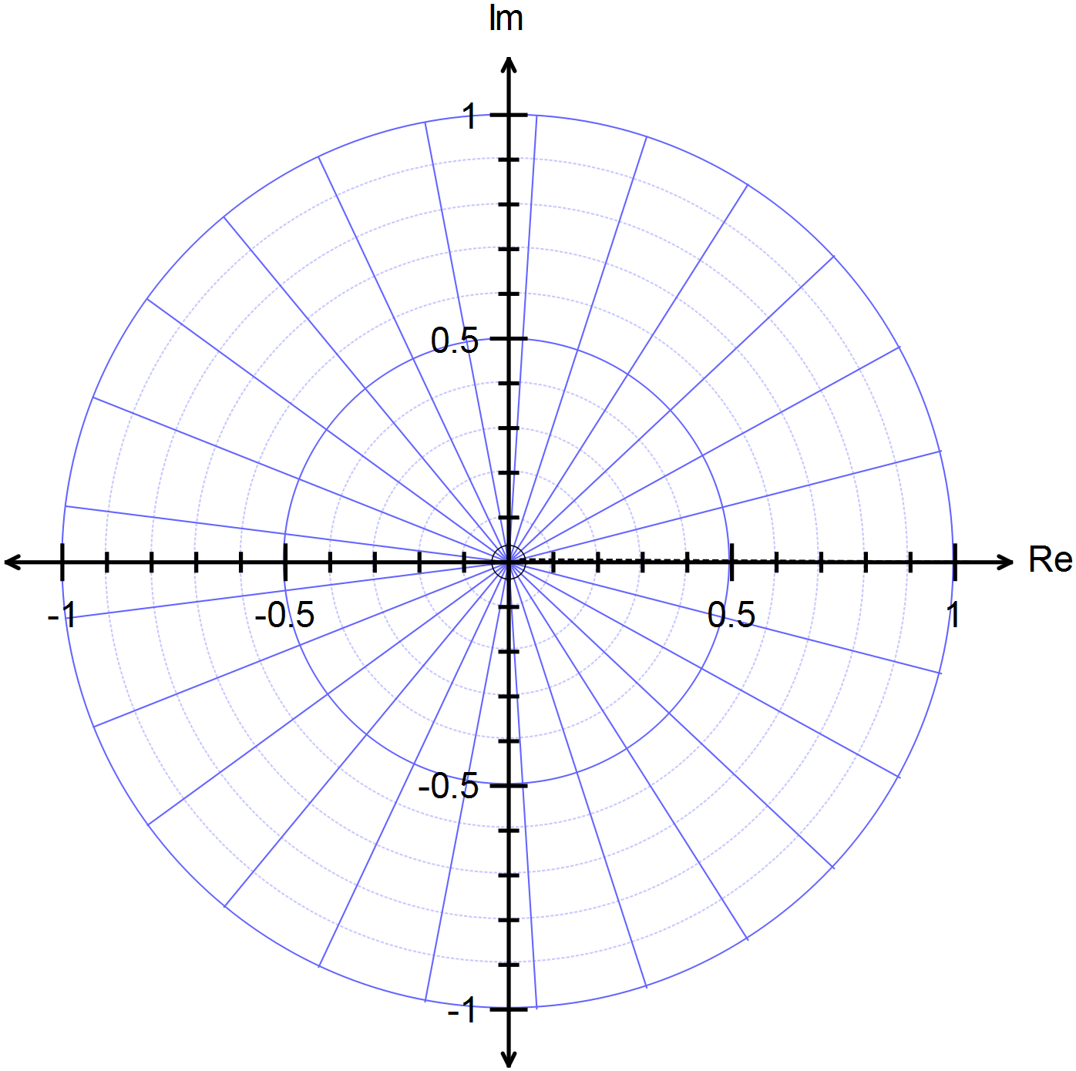

**Question 4 (8 marks)**



. (3 marks)

. (5 marks)

**Section Two – calculator-assumed section (20 marks)**

**Question 5 (10 marks)**

1. Expand and simplify the expression. (2 marks)
2.  (3 marks)
3. Use to solve the equation and express the solutions in trigonometric form. (5 marks)

**Question 6 (10 marks)**



(a)  (4 marks)

(b) . (6 marks)

# 

# Solutions and marking key for Test 1 for concurrent Unit 3 and Unit 4 program

**Section One – calculator-free section (30 marks)**

**Question 1 (3.1.6, 3.1.15) (8 marks)**

(a)  (2 marks)

|  |  |  |
| --- | --- | --- |
|  | | |
| **Specific behaviours** | **Mark** | **Item** |
| Expands the Cartesian form of *z*6  Simplifies correctly | 1  1 | simple  simple |
| **Or**  Expresses *z*6 in polar form  Expresses the answer in Cartesian form | 1  1 | simple  simple |

1. (4 marks)



|  |  |  |
| --- | --- | --- |
|  | | |
| **Specific behaviours** | **Mark** | **Item** |
| Writes the Cartesian form of  correctly  Writes the Cartesian form of  correctly  Expresses polar term for  in Cartesian form  Simplifies the Cartesian form correctly | 1  1  1  1 | simple  simple  complex  complex |

(c)  (2 marks)

|  |  |  |  |
| --- | --- | --- | --- |
|  | Or | | |
| **Specific behaviours** | | **Mark** | **Item** |
| Completes the square correctly  Solves the equation using the exact form  **Or**  Uses the quadratic formula  Simplifies the expressions to the correct exact form | | 1  1  1  1 | simple  simple  simple  simple |

**Question 2 (1.1.7) (6 marks)**

(a) .

|  |  |  |
| --- | --- | --- |
|  | | |
| **Specific behaviours** | **Mark** | **Item** |
| Draws a circle  Has the correct centre *(2 + 3i)*  Has the correct radius  Circumference passes through *(0, 0) (4 + 0i)* and *(0 + 6i)* | 1  1  1  3 | simple  simple  simple  simple |

**Question 3 (3.1.11, 3.1.12) (8 marks)**

Determine and locate all solutions in the Argand plane to the equation .

|  |  |  |  |  |
| --- | --- | --- | --- | --- |
|  |  |  | | |
| **Specific behaviours** | | | **Mark** | **Item** |
| Expresses the five solutions correctly  Locates the solutions accurately on a polar graph | | | 5  3 | simple  simple |

**Question 4 (3.1.13, 3.1.15) (8 marks)**

:

 (3 marks)

|  |  |  |
| --- | --- | --- |
|  | | |
| **Specific behaviours** | **Mark** | **Item** |
| Evaluates each of the three terms | 3 | simple |

 (5 marks)

|  |  |  |
| --- | --- | --- |
|  | | |
| **Specific behaviours** | **Mark** | **Item** |
| Uses the factor theorem to give factors  Determines the remaining factors  Correctly writes all the roots | 1  2  2 | simple  complex  complex |

**Section Two – calculator-assumed section (20 marks)**

**Question 5 (3.1.7) (10 marks)**

1. Expand and simplify the expression  (2 marks)

|  |  |  |
| --- | --- | --- |
|  | | |
| **Specific behaviours** | **Mark** | **Item** |
| Shows the real and imaginary terms correctly | 2 | simple |

1.  (3 marks)

|  |  |  |
| --- | --- | --- |
|  | | |
| **Specific behaviours** | **Mark** | **Item** |
| Writes the real part of  Substitutes for  Gives the correct expression for | 1  1  1 | simple  simple  simple |

1. Use and express the solutions in trigonometric form. (5 marks)

|  |  |  |
| --- | --- | --- |
|  | | |
| **Specific behaviours** | **Mark** | **Item** |
| Uses De Moivre to state  Makes the substitution in polynomial  Replaces the polynomial in with  Solves in terms of  Gives all five solutions in terms of *x* | 1  1  1  1  1 | complex  complex  complex  complex  complex |

**Question 6 (3.1.7) (10 marks)**



1.  (4 marks)

|  |  |  |
| --- | --- | --- |
|  | | |
| **Specific behaviours** | **Mark** | **Item** |
| Rewrites the complex numbers  in trig form  Simplifies both numerator and denominator  Writes the correct final term | 2  2 | simple  simple |

(b)  (6 marks)

|  |  |  |
| --- | --- | --- |
|  | | |
| **Specific behaviours** | **Mark** | **Item** |
| Gathers terms and simplifies    Gathers terms and simplifies  Equates both equations  Writes correct final expression | 1  1  1  1  1  1 | complex  complex  complex  complex  complex  complex |

|  |  |  |  |  |  |  |  |
| --- | --- | --- | --- | --- | --- | --- | --- |
| Question | 1 | 2 | 3 | 4 | 5 | 6 | Total |
| Simple | 8 | 6 | 8 | 4 | 5 | 4 | 35 |
| Complex | 0 | 0 | 0 | 4 | 5 | 6 | 15 |
|  | 8 | 6 | 8 | 8 | 10 | 10 | 50 |